Writing on PDF – 3 easy steps
Click the purple button at the right hand side;
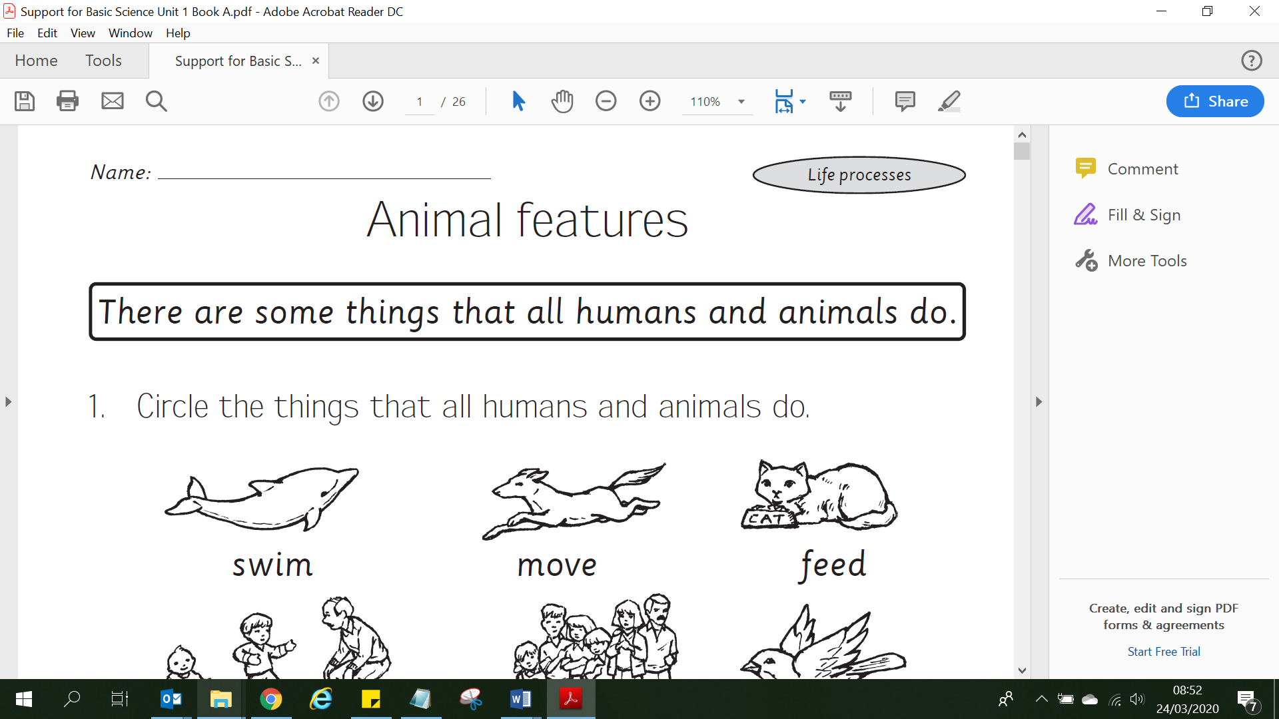
Click where you want to write your answer and type;
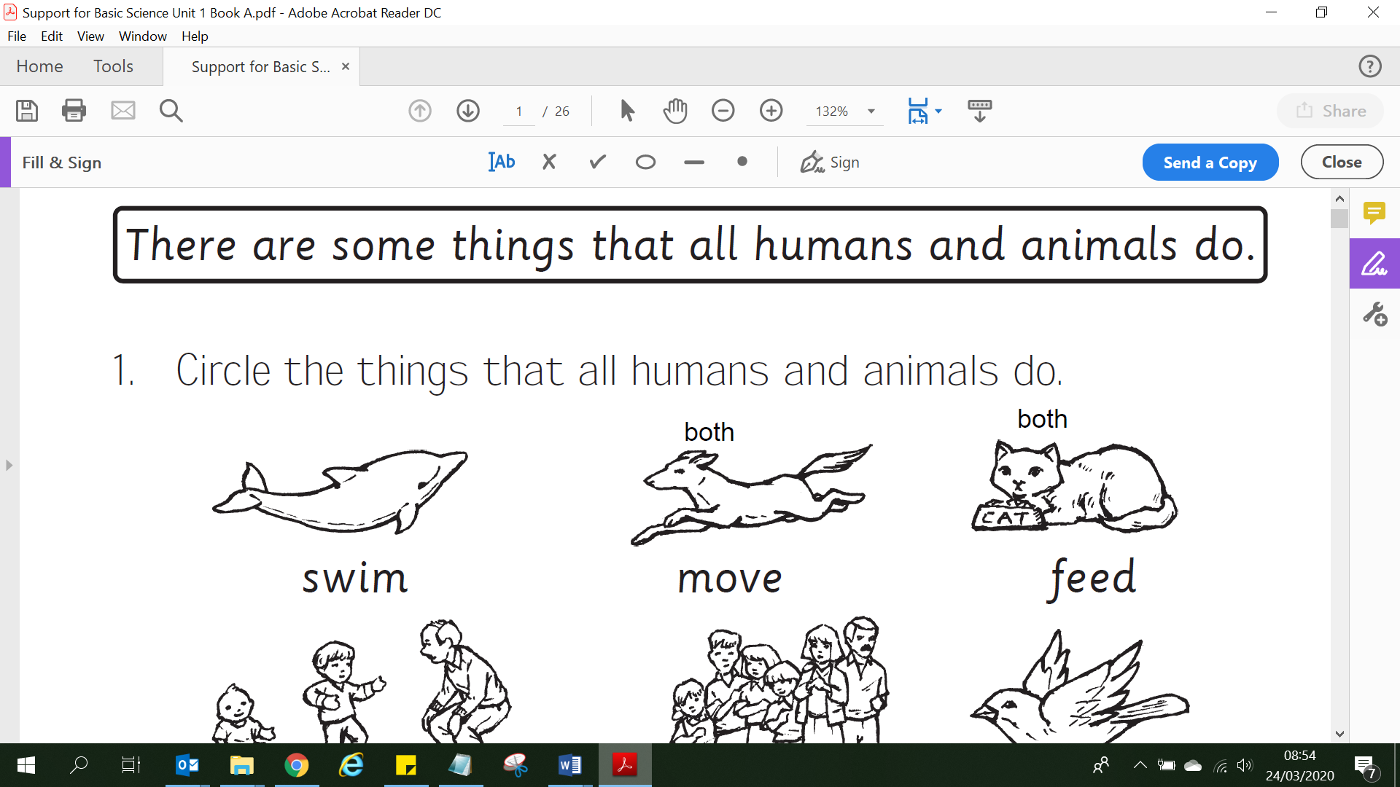

Save!
