

**NES Year 6**

**Transition booklet 2**

* **All About Me**
* **Fantastic fundraising**
* **Rewarding Reading**

**When you join The Nottingham Emmanuel School in September you will spend some time getting to know your tutor and the other students in your tutor group. In order to prepare you for this, we would like you to have a go at the activities in this booklet and bring them with you to show your new tutor.**

1. **All About Me- Speech**

When you join your tutor group in September we would like you to present a short speech that you can deliver to your tutor group to help them to get to know you. To help you plan your speech there are a list of questions below that you might want to answer however, these are just a guide and you don’t have to follow them in order. Be as creative and interesting as you can!

|  |  |
| --- | --- |
| **Question** | **How could I introduce this in my speech?** |
| What is your name? | “My name is….” |
| What primary school did you go to? | “I attended ………….. Primary School” |
| What was your favourite subject at primary school? Why did you enjoy this subject? | “My favourite subject at primary school was……….. this is because…. Additionally…….” |
| What new subjects are you looking forward to at secondary school? Why? | “At secondary school I am really looking forward to…. this is because…….” |
| What enrichment activities (clubs) are you looking forward to at secondary school? | “I am also looking forward to trying out………this is because….” |
| Do you have anything else you would like people to know about you? | “In addition to this, I would like to tell you…….” |

You should plan and practise your speech at home. In order to help you deliver your speech, you may want to create a poster that you can use as a prompt when you are doing your speech in class. Your poster could include pictures or photos and key words that you can refer to. You can also use the hints and tips below to help you plan your speech.

Don’t forget that a great speaker will be:

* Clear
* Loud enough to hear- without shouting
* Not speaking too fast or too slowly
* Looking at the audience

Use the pictures below to think about the different ways you can change your voices when performing your speech.





1. **Fantastic fundraising**

When you join the Nottingham Emmanuel School you will be part of one of the four houses- Romero, King Junior, Booth or Pullinger. These four Houses embody the four school values of wisdom, community, hope and dignity and the activities that you carry out in your House will be in line with these values. Within your House, you will complete against other Houses in a variety of challenges, aim to gain as many house points as possible and also serve your House and your chosen House charity.

Each House supports a charity by carrying out a variety of fundraising activities throughout the year. The charities are outlined below. We would like you to think of a fundraising activity that you could carry out with your tutor group in school to raise money for your House charity. You should use the template on the next couple of pages to help you to plan your fundraising idea. We can’t wait to hear your ideas in September!

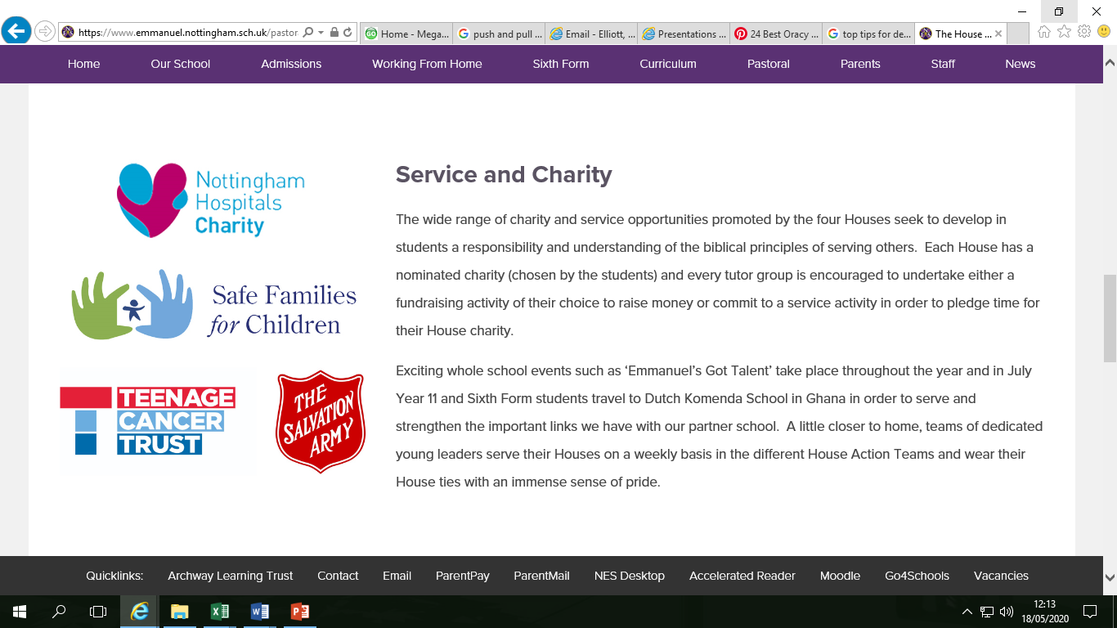**Nottingham Hospitals Charity**- This charity supports the best health care for patients by using donations to provide life-saving equipment, improving facilities and carrying out medical research.

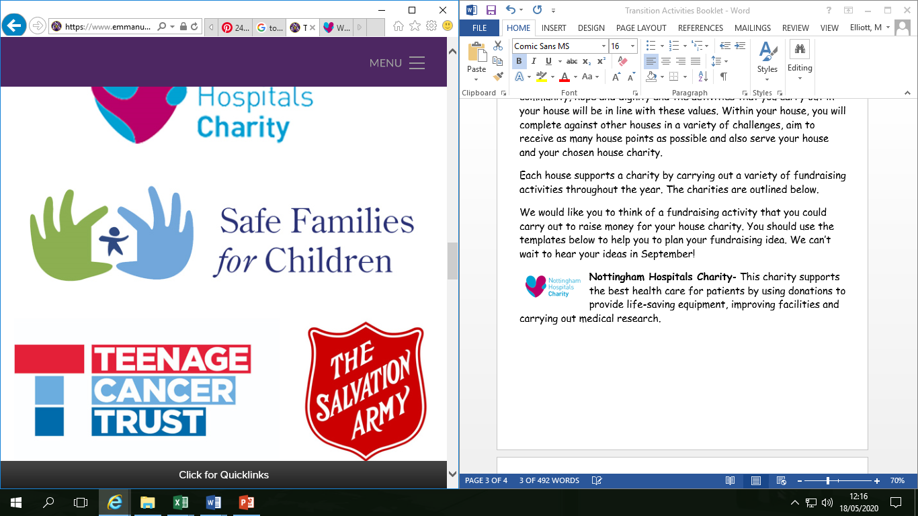**Safe Families for Children-** This charity offers hope, belonging and support to children and families around the UK. They work with 4,500 volunteers from churches and community groups.

**The Salvation Army-** This charity has been transforming lives for over 150 years. They have 750 community churches and social centres where they offer friendship, practical help and support. They work on homelessness, poverty, addition and many other things.

**Teenage Cancer Trust**- This charity help to provide nursing care and support during very tough times when young people get cancer. They put the needs of young people first.

***My Fundraising Ideas***

Draw a spider diagram to show your initial ideas for ways that you could raise money at school for your House charity.

***Now choose your favourite idea from your spider diagram. Use the template below to plan your activity.***

My fundraising idea is (describe what you will do to raise money):

I think that this will be a good way to raise money because…

What equipment will you need?

How many other people will you need to help you? What will each person need to do?

How will you let other people know about your fundraising activity?

What help will you need from your form tutor or head of house?

When will you meet with these people to plan your fundraising activity?

1. **Rewarding Reading**

Do you have a favourite book that you have read that you would like to recommend to others? Fill in the book review below, give it to your tutor in September and it will be added to our book review display in the library. When you visit the library to will be able to read other people’s reviews and choose your next book to read!

Book Review by:

Title:

Author:

Non Fiction or Fiction

What is the book about?

Who would this book be suitable for?

Would you/ would you not recommend this book? Why?



Book Illustration