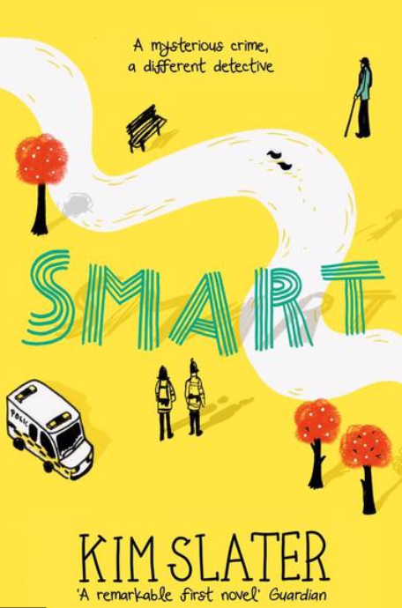

By Kim Slater

At the Nottingham Emmanuel School, we love reading and sharing books as a community. When you join us in Year 7, you will be reading SMART, a book written by Kim Slater. You’ll read this once a week with your tutor group. This amazing book is set in in the Meadows in Nottingham so there will be lots of places that you recognise!
In order to prepare to come to NES in September, we would like you to try to tackle as many of the following activities as you can and bring them in to show your new tutor. All of the activities relate to the book but don’t worry, you don’t need to have read it at this stage, we will be doing that together in September.
We can’t wait to see how many tasks you have done!

Task 1: What does the title mean?

Definition:  What does the word ‘smart’ mean? You can use a dictionary or an online dictionary (using google) to help you. | Connotations:  What does the word ‘smart’ make you think about?  Can you think of other words that mean ‘smart’ (synonyms)?
Examples:  Who do you think is ‘smart’ and why | What it’s not:  If someone isn’t ‘smart’, how would you describe them? How many words can you think of?

Task 2: What can you predict from the front cover?
Look at the cover of the book and then make a prediction about what the book will be about.
- What do you think will happen in the story? Tell me why you think this – make reference to different parts of the front cover.
- Who do you think the narrator will be? (the main character who tells the story)
What clues can you spot? ____________________________________________________________________________________________________________________________________________________________________________________________________________________________________________________________________________________________________________

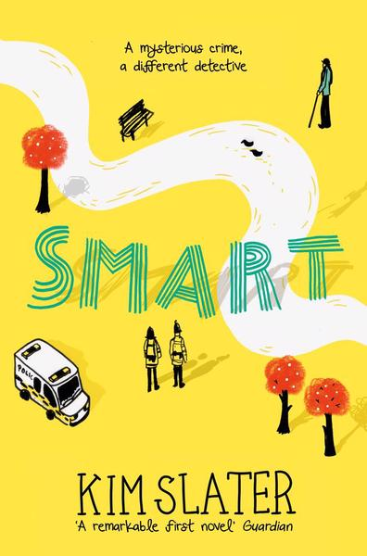
I think that SMART will be about_____________________________________________________________________________________________________________________________________________________________________________________________________________________________________________________________________________________________________________________________________________________________________________________________________________________________________________________________________________________________________________________________________________________________

Task 3: What do you learn from the Blurb?
Kieran cares. He’s made a promise, and when you say something out loud, that means you’re going to do it, for real. He’s going to find out what really happened. To Colin. And to his grandma, who just stopped coming round one day. It’s a good job Kieran’s a master of observation, and knows all the detective tricks of the trade.
But being a detective is difficult when you’re Kieran Woods. When you’re amazing at drawing but terrible at fitting in. And when there are dangerous secrets everywhere, not just outside, but under your own roof.
____________________________________________________________________________________________________________________________________________________________________________________________________________________________________________________________________________________________________________________________________________________________________________________________________________________________________________________________________________________________________________________________________________________________________________________________________________________________________________________________________________________________________________________________________________________________________________________________________________________________________________________________________________________________________________________________________________________________________________________________________________________________________________________________________________________________________________________________________________________________________________________________________________________________________________

Task 4: What do you know about detective stories?
On the cover of this book it says ‘A mysterious crime, a different detective’. We know that this is going to be a story about a detective.

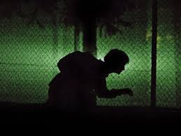

What does a detective do?
____________________________________________________________________________________________________________________________________________________________________________________________________________________________________________________________________

Do you know any famous detectives? How many can you list?
________________________________________________________________________________________________________________________________________________________________________________________________________________________________________________________________________________________________________________________

Sherlock Holmes is a famous detective (You will read a book about him in Year 10). Do some research and find at least 5 facts about Sherlock. You could use this link to help you: https://kids.kiddle.co/Sherlock_Holmes
1. _________________________________________________
2.__________________________________________________
3.__________________________________________________
4.__________________________________________________
5.__________________________________________________

What would a detective work out from the following clues?
Clue | What I can work out from this clue:
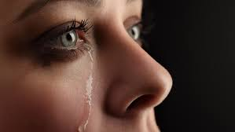
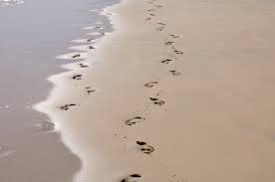

Task 5: Where is the book set and how can I understand this setting better?
We know that SMART is set in Nottingham and a lot of the events in the story take place around the River Trent and the embankment which is very close to The Nottingham Emmanuel School.
In the box on the next page, draw your route to school. You might want to go for a walk to practise with your family and have a look at the building before your first day.

Is there any key information you need to jot down to help you with your route?
You can add the number of your bus, cost of a ticket or important road names to help you!

Task 6: Where is the book set and what would I see there?
It is not often that you can actually visit the place where a story is set. We know that this isn’t a real story but it is about a real place.
Take a walk along the Embankment starting at the Toll Bridge (where the tram goes from Wilford to the Meadows) and see if you can spot any of these things that Kieran talks about in the book.

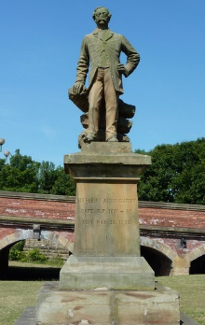
If you see them, put a tick in the box next to them.
- The statue of Sir Robert Juckes Clifton.
This statue is close to the toll bridge and faces away from the bridge. It depicts the man that arranged the building of the bridge. Both he and his wife were incredibly popular for their work and generosity, because they paid for a church in Clifton and a new school for the people of Clifton. His family owned Clifton Hall which you can still see in Clifton Village. If you would like to know a bit more you can follow this link: http://www.bbc.co.uk/nottingham/content/articles/2009/09/22/worst_sculptured_trousers_feature.shtml

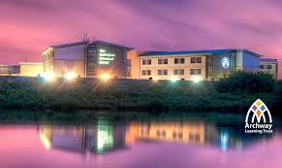
- The Nottingham Emmanuel School
If you look across the river about half way down the Embankment you will be able to see the Nottingham Emmanuel School. The School is relatively new as it was founded in September 2002 and the building that you can see was completed in 2008.

- Coots- How many did you see? Make a tally as you walk down the river
All-black and larger than its cousin, the moorhen, the coot has a distinctive white beak and 'shield' above the beak. It patters noisily over the water before taking off and can be very aggressive towards others.

- Swans (Mute swans) - How many did you see? Make a tally as you walk down the river.
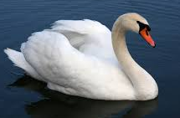
The mute swan is a very large white water bird. It has a long S-shaped neck and an orange bill with a black base and a black knob. The population in the UK has increased recently, perhaps due to better protection of this species.

- Moorhens- How many did you see? Make a tally as you walk down the river.
Moorhens are blackish with a red and yellow beak and long, green legs. Seen closer-up, they have a dark brown back and wings and a more bluish-black belly, with white stripes on the flanks.

- Canada Geese- How many did you see? Make a tally as you walk down the river.
The Canada goose is a large goose, with a distinctive black head and neck. It forms noisy flocks and is often regarded as a nuisance in areas where large numbers occur on grassland and parks.

- Herons- How many did you see? Make a tally as you walk down the river.
Grey herons are unmistakeable: tall, with long legs, a long beak and grey, black and white feathering. They can stand with their neck stretched out, looking for food, or hunched down with their neck bent over their chest.

Bird: | Tally: | Total number spotted:
Coot
Mute Swan
Moorhen
Canada goose
Heron

Did you see anything else on your walk?
________________________________________________________________________________________________________________________________________________________________________________________________________________
Task 7: Who is Lowry and how can I create work like his?
The main character in this book is called Kieran. He is a fantastic artist and loves the work of L. S Lowry.
Lowry liked to draw city landscapes.
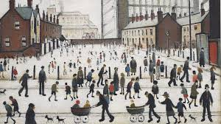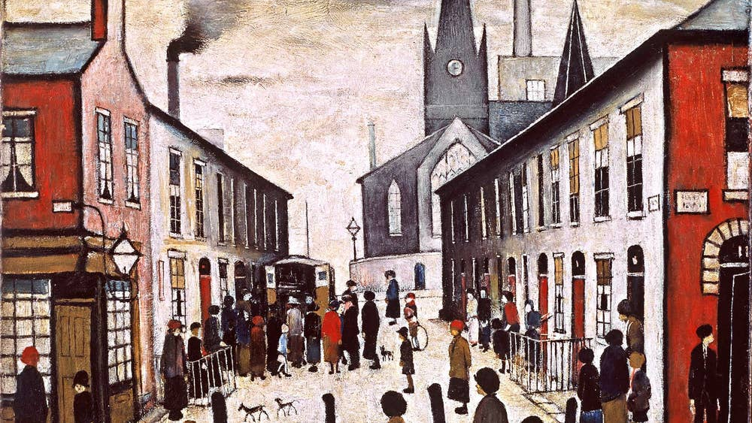
What do you notice about these pictures?

Choose a place in Nottingham to draw. Here are some ideas, but you can pick a place of your own if you would like to.
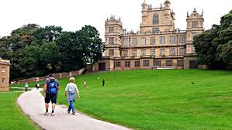
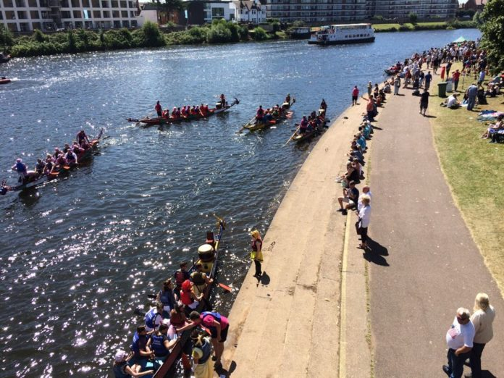
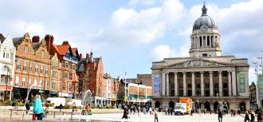

Draw your landscape on the next page:

Why have you chosen to draw this location in Nottingham?

Task 8: What is the main character of this book like and what is your first impression of him?
Read this chapter
The Letter
One day I’m going to be a reporter for the Evening Post. That’s why I started walking straight home, so I could write stuff down.
I don’t write in my notebook all of the time. I used to only write in it when bad things happened like when Grandma stopped coming around.
But now I write down all the interesting things that happen too, so the editor of the Post will want me to work for him when I leave school. I can show him my notebook as evidence of my reporting skills.
The bad thing at the river was definitely interesting.
I can do the tiniest writing in the world; even I can’t read it sometimes. Nobody can tell other people what I’ve said, which is the best thing. You can’t trust people, but you can trust your notebook.
I ripped out all the pages of my old Beano annual and I hide my notebook in there. Then I put the annual in the middle of a pile of annuals under the bed. Nobody will ever find it.
See, this is why I like writing in my notebook. I can talk about anything that’s ever been invented and no one can tell me off.
I am in charge.
You can write sentences with only one word in them, like that. It’s your choice.
I live in Nottingham. Not right in the middle, where the castle is, just at the edge of the middle.
‘Just outside the city centre,’ Miss Crane says.
I like saying ‘edge of the middle’ better. It feels more like a place.
Robin Hood came from Nottingham. He lived in Sherwood Forest and formed a merry band of men, including Little John, who was massive. Yorkshire tried to steal Robin Hood. They said he came from there but it’s been proven by scientists that he was from Nottingham.
I stopped walking for a minutes and looked back at the embankment and the flashing blue lights of the police van.
Sometimes, when I look at the river I imagine it is a long, thin piece of sea. If you followed it for nearly a year, you would reach Australia. It’s been here as long as Robin Hood. He might have stood in some of the exact places I do, looking at the river. I said that once. To my older brother.
‘Course he did, ‘he replied.
Ryan is my older brother but not a proper one. I’ve got a different mum and dad to him.
My dad died. I only know him because of the photographs that mum kept to show me. I was just a baby then.
Are there any words you are unsure of? Write them below.

What could you do to help you understand what these words mean?
What have you learnt about Kieran?

What questions do you have about the story? Is there anything you are curious about?

What is…?
Who is…?
Why have,,,?

What predictions (guesses) can you make about the book or the story from this?

I think that…
I predict that…
It could be that…
Based on evidence from the text, I guess that…

Task 9: What is the Nottingham Evening Post?
Kieran says in the chapter that he wants to be a reporter for the Evening Post.
What is the Evening Post? Research about what it is and it’s history and record some of your learning below! You can have a look online here: https://www.historic-newspapers.co.uk/blog/nottingham-evening-post-history/
All about the Nottingham Evening Post

Task 10: Kieran’s feelings
Put yourself in Kieran’s shoes.
Complete the role on the wall below about everything you know about him from reading this.
Use these question prompts to help you think from his view:
- What would he be thinking?
- What would he be saying out loud?
- What would he be feeling at that point in the chapter?
- What would his reactions be towards others?
- What gestures or interactions would he make with others?
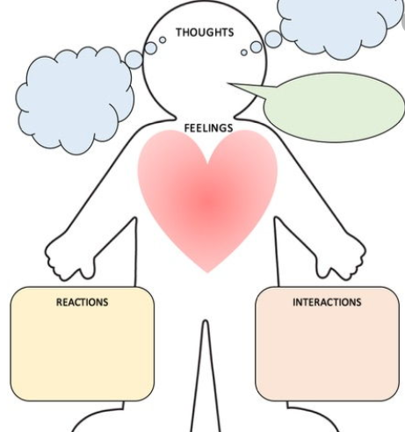

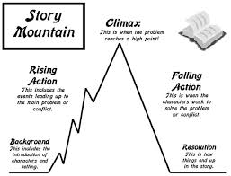
Task 11: Can you write a story that is set in Nottingham?
Write your own story set in Nottingham. You might want to consider what you know about Nottingham and how you can show that this is Nottingham and not any other city in England.

Let’s plan the structure:
How will the story begin?

What will the problem be in the story?

How will you make your reader want to read more? (Make it exciting, worrying scary?)
What kind of ending will your story have?
Setting:
Where will it be set? You could choose one of these places, but you can choose you own.
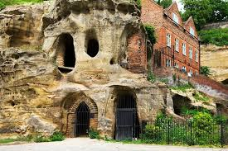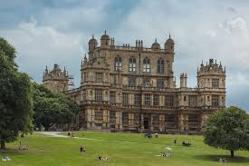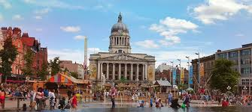
What would you see in this place?
Things I would see: | Words and phrases I can use to describe them  Challenge: Can you use a simile (say something is like something else or as___ as something else), a metaphor (saying something is something that it isn’t really) or personification (giving something that isn’t alive qualities of a living thing)?
Nottingham Castle | The gargantuan, towering castle upon the grassy hill in the distance was like a spooky, haunted house.
Character: Can you write as if you are a character in the story? This means you will say ‘I’.
Who are you going to be?
Name:
Age:
Job:
Family:
Key features that make them standout:
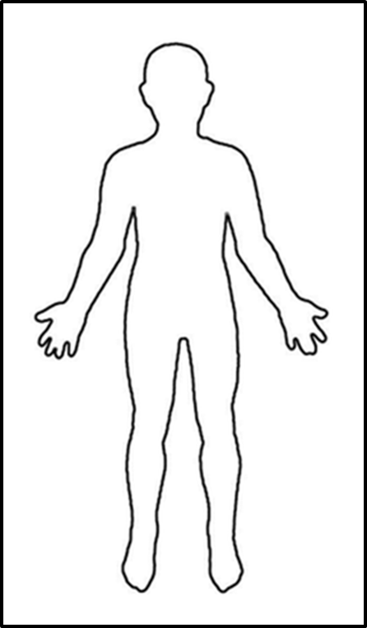

Face:

Hair:

Behaviour:
Walk:
Talk:
Look at people:
Other:
Behaviour:
Walk:
Talk:
Look at people:
Other:
Hair:

Clothes/Body:

Write your story here:
________________________________________________________________________________________________________________________________________________________________________________________________________________________________________________________________________________________________________________________________________________________________________________________________________________________________________________________________________________________________________________________________________________________________________________________________________________________________________________________________________________________________________________________________________________________________________________________________________________________________________________________________________________________________________________________________________________________________________________________________________________________________________________________________________________________________________________________________________________________________________________________________________________________________________________________________________________________________________________________________________________________________________________________________________________________________________________________________________________________________________________________________________________________________________________________________________________________________________________________________________________________________________________________________________________________________________________________________________________________________________________________________________________________________________________________________________________________________________________________________________________________________________________________________________________________________________________________________________________________________________________________________________________________________________________________________________________________________________________________________________________________________________________________________________________________________________________________________________________________________________________________________________________________________________________________________________________________________________________________________________________________________________________________________________________________________________________________________________________________________________________________________________________________________________________________________________________________________________________________________________________________________________________________________________________________________________________________________________________________________________________________________________________________________________________________________________________________________________________________________________________________________________________________________________________________________________________________________________________________________________________________________________________________________________________________________________________________________________________________________________________________________________________________________________________________________________________________________________________________________________________________________________________________________________________________________________________________________________________________________________________________________________________________________________________________________________________________________________________________________________________________________________________________________________________________________________________________________________________________________________________________________________________________________________________________________________________________________________________________________________________________________________________________________________________________________________________________________________________________________________________________________________________________________________________________________________________________________________________________________________________________________________________________________________________________________________________________________________________________________________________________________________________________________________________________________________________________________________________________________________________________________________________________________________________________________________________________________________________________________________________________________________________________________________________________________________________________________________________________________________________________________________________________________________________________________________________________________________________________________________________________________________________________________________________________________________________________________________________________________________________________________________________________________________________________________________________________________________________________________________________________________________________________________________________________________________________________________________________________________________________________________________________________________________________________________________________________________________________________________________________________________________

We look forward to meeting you at the Nottingham Emmanuel School and reading the rest of the book to find out the answers to your questions and see if your predictions were correct!

Produced by the Nottingham Emmanuel School in collaboration with Sneinton C of E School

