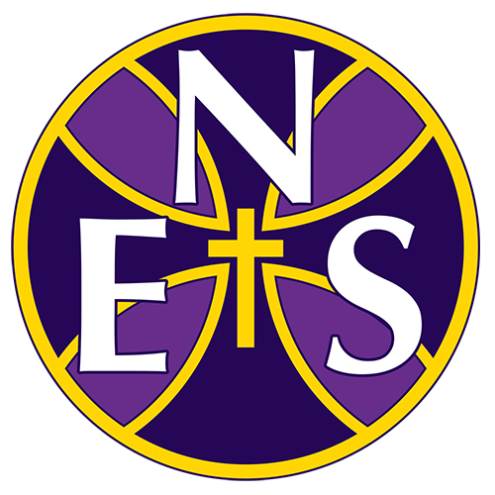
Collective Worship
Statement of Practice
Our Christian Mission is:
“I am able to do all things through Christ who strengthens me”
Philippians 4:13

Our Christian Values are: Wisdom, Hope, Community and Dignity

vraynor@bluecoat.uk.c

Document Owner | Assistant Principal
Date reviewed | March 2021
Approved by AAB | June 2021

Collective Worship at the Nottingham Emmanuel School
Statement of Practice
All maintained schools must provide religious education and daily collective worship for all registered pupils and promote their spiritual, moral and cultural development.
At The Nottingham Emmanuel School, we are very proud of the way in which we work with pupils to achieve their very best academically as well as developing their character. Our faith underpins everything we do here; this is lived out in daily worship across our school. It is important to us that all members of our school community are given regular opportunities to explore faith through practising meaningful worship and prayer and showing respect to other members of the school community with different beliefs from theirs. This worship is central to the day-to-day life of our school and our hope is that it encourages both students and adults to see themselves as spiritual beings and explore how they interact with the world, with others and with God. Not only is this a legal requirement (See DfE circular 1/94), but it is also something we are deeply passionate about as a Church of England Academy. We are clear when explaining to prospective parents that worship is a significant part of the day-to-day experience of all members of our family here at The Nottingham Emmanuel School and we hope that all staff and students will be enriched by their participation in this, irrespective of their religion or beliefs.
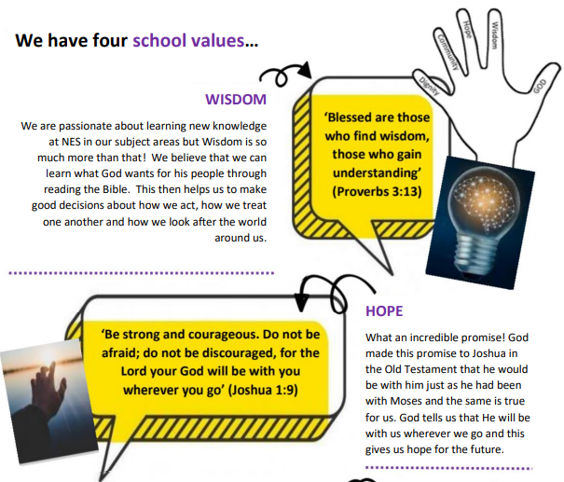
Collective Worship at Nottingham Emmanuel School is centred around our core values; Hope, Community, Dignity and Wisdom. The following pieces of scripture are associated with each of these core values:

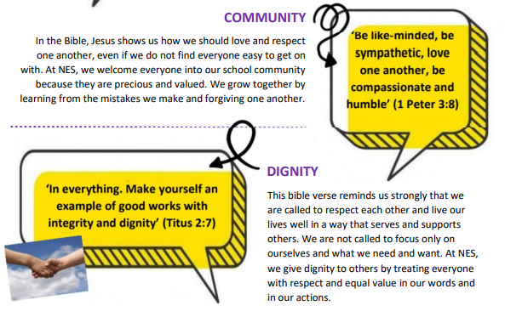
Weekly Worship Rota
Opportunities for both staff and students to engage in prayer and worship are outlined below:
 | Year 7 | Year 8 | Year 9 | Year 10 | Year 11 | Years 12 and 13
Monday | Year group collective worship | PSHE  Prayer in tutor groups | PSHE  Prayer in tutor groups | PSHE  Prayer in tutor groups | PSHE  Prayer in tutor groups | Sixth Form  Collective Worship
Tuesday | PSHE  Prayer in tutor groups | Year group collective worship | NES Reads  Prayer in tutor groups | NES Reads  Prayer in tutor groups | Year group collective worship | Sixth Form Tutor Programme  NES Reads
Wednesday | NES Reads  Prayer in tutor groups | NES Reads  Prayer in tutor groups | Year group collective worship | Year group collective worship | Targeted Intervention  Prayer in tutor groups | Sixth Form Tutor Programme  PSHE / VESPA
Friday | House collective worship  (alternates with) Archway Faith Tutor Activity |  |  |  |  | Sixth Form Tutor Programme  PSHE / VESPA

Year Group Collective Worship
These usually take place with a single year group. Worship leaders may be members of staff, student leaders or external leaders from churches or other reputable organisations. All of our collective worship follows agreed Christian themes shared across the Trust. When external leaders are used, these are supported by SLT and the Christian Youth Worker to ensure quality; theology and purposefulness of delivery. The aim of collective worship in this setting is to give all members of our family a chance to meet God or at the very least, to stop and take time to reflect on their lives and their relationships. Our worship is distinctively Christian but extremely inclusive and relevant to all. During 2020-2021 and in response to the pandemic, we have collaborated in and developed weekly Archway Faith AOW (recorded and shared across the Trust) which feature our Christian Youth workers, staff, students and visiting speakers and allow us to worship as a larger Christian community of three secondary schools.
House Collective Worship
House Collective Worship takes place fortnightly and each House worships together lead by their Head of House. Heads of House may lead these acts of worship accompanied by members of staff, departments, house captains or external visitors linked to our Houses (service and charity representatives). The aim of collective worship in this setting is to challenge students to live life in all its fullness (John 10:10), encourage servant-hearted leadership in our community and challenge one another to live out our faith in both the local, national and international communities. During 2020-2021 and in response to the pandemic, House Collective Worship has been delivered via Microsoft Teams to ensure that tutor groups can still take part in the collective worship experience from their own tutor bases.
Archway Faith Tutor Activity
The Archway Faith tutor activity (which takes place alternate weeks) is an act of worship during tutor time. These sessions are always focused on a biblical text. Staff and students are given the opportunity to read, reflect and respond to this text in their daily lives. All texts are accompanied by a particular theme or are aimed at engaging with an inspirational biblical figure with the aim of making students more biblically literate. We also encourage all, to critically engage with the Christian narrative so as to deepen their own understanding and faith. These times not only offer periods of silence and stillness, but they also encourage collaboration and discussion which is very important to us here at The Nottingham Emmanuel School.
Prayer in tutor groups
During tutor time, NES students engage in important PSHE activities as part of their PSHE curriculum as well as developing their literacy through our NES Reads program. It is very important to us that whatever is happening in tutor time, before students and staff go out to their lessons, there is a moment for stillness and prayer. This is key to the harmonious atmosphere we expect to maintain at The Nottingham Emmanuel School. It is an opportunity for students to engage, in a smaller setting, with prayer and worship. In doing so, we want students to see the importance of acknowledging God in the day to day. Staff and students may choose to use the NES School Prayer at these times, lead prayers themselves or invite students to lead their peers in prayer.

Holy Communion
At The Nottingham Emmanuel School, we celebrate Holy Communion regularly. This is important as we follow Jesus’ command to “do this in remembrance [of Him].” This is a fantastic opportunity for staff and students to respond in faith by receiving Holy Communion. This is a very personal decision, which we believe is between God and the individual deciding. No one is forced or coerced into receiving Holy Communion but we still gather for this sacrament as a whole family. It is a time where all pay respect to our distinctively Christian ethos by engaging with the teaching and the message given by a local vicar. It is also a time for all to be respectful and reflective. Students are encouraged to engage in the most appropriate way for them; receive communion, go for prayer, light a candle or observe. Our staff and student worship band play an active role in each service of Holy Communion. During 2020-2022 we have been unable to celebrate Holy Communion due to the pandemic but hope to resume this practice in the Summer of 2022.

Liturgical Calendar
We join with the Christian Church around the world to celebrate both Christmas and Easter with larger acts of collective worship. We have lots of activities and events happening in school around these times, and all students are involved in celebrating these occasions and reflecting on the lessons that can be learned from them. We join in with the Church of England liturgical calendar on a number of occasions over the academic year such as:
- Advent: We hold an annual Carol Service where we invite the NES family (both our school community and our Church of England feeder primaries) to take part. The key message is delivered by one or more of our Sixth Form students.
- Lent: We hold ‘Cloister’ events run by our Christian Youth Worker and partners from local churches that encourage students to engage in faith based activities outside in the school cloister
- Easter services: These focus on why Easter is such an important part of the Christian faith.
- National Calendared Events such as Thy Kingdom Come and those that are important to us at The Nottingham Emmanuel School such as: Black History Month, Mental Health Awareness Days etc.

People Responsible:
Sarah Anderson (SLT – NES)
Kirsty Lacey – ALT Lead Teacher of Christian Distinctiveness (BAA)
Nicola Goss– Assistant Lead of Christian Distinctiveness (BWA)
Symonne Banton – Christian Youth Worker (NES)
David Riggs – Christian Youth Worker (BWA)
Eleanor Walton - Christian Youth Worker (BWA)
Letitia Wright - Christian Youth Worker (BWA)
NES Head of House Team (Symonne Banton, Charlotte Bassett, Amy Ratcliffe and Elliott Walker)
The team are responsible for the planning and coordination of the different worship and Christian events held throughout the year. If you have any questions regarding the above. Please do not hesitate to get in touch.

