HOW TO PURCHASE YOUR UNIFORM
2023/24

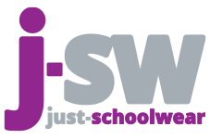

To ensure your child has their uniform ready for their first day, all orders MUST be placed by Friday 4 August

Uniform can ONLY be purchased from Just-Schoolwear website, where you have two options for delivery:

Option 1: Free Click & Collect from any of the Just-Schoolwear stores
Option 2: Home Delivery (£4.94)

Uniform Sizing Event

We have Just School Wear joining us for our family induction evening on 4th July 2023
Please arrive at least an hour prior to your allocated induction timeslot to attend the sizing event.

How to locate The Nottingham Emmanuel Uniform?

Go to www.just-schoolwear.co.uk
- Click ‘Shop’ on the drop down menu at the top of the webpage
- Then type ‘The Nottingham Emmanuel School’ in the search bar

Shop opening times – For Click & Collect + Returns (the stores will not hold any uniform stock, only a sizing set)

Shop/Day | Monday | Tuesday | Wednesday | Thursday | Friday | Saturday | Sunday
Arnold  (Just-schoolwear) | Closed | 10am-4pm | Closed | 10am-4pm | Closed | 10am-3pm | Closed
Long Eaton  (Just-schoolwear) | Closed | Closed | 10am-4pm | Closed | Closed | 10am-3pm | Closed
West Bridgford  (Just-schoolwear) | Closed | 10am-4pm | Closed | 10am-4pm | Closed | 10am-3pm | Closed

Please check the Just-Schoolwear website from 23 July, as some stores will have extended opening times.

Uniform Prices
NOTTINGHAM EMMANUEL SCHOOL PRICE (£)
Nottingham Emmanuel School Blazer* | £26.75 – £32.95
Nottingham Emmanuel School Clip On Tie* | £5.95
Ecro Apron | £7.95
Black V-Neck Jumper | £16.95 - £19.95
Trutex Stitch Down Pleated Skirt | £17.95 – 20.95
Trutex Slim Leg Trouser | £17.95 – 20.95
Long Sleeve Trutex Boys Shirt ( Twin Pack) | £14.95 - £16.95
Short Sleeve Trutex Girls Blouse ( Twin Pack) | £14.95 - £16.95
NOTTINGHAM EMMANUEL SCHOOL PE UNIFORM PRICE (£)
Nottingham Emmanuel School Embroidered PE Polo shirt* | £10.50 - £12.50
Black Honeycomb sports shorts | £8.50 - £9.50
Falcon Training Pants | £20.95
Nottingham Emmanuel School PE Varsity Hoodie | £17.95 - £20.95
Black Sports Socks | £5.95
*Compulsory Items

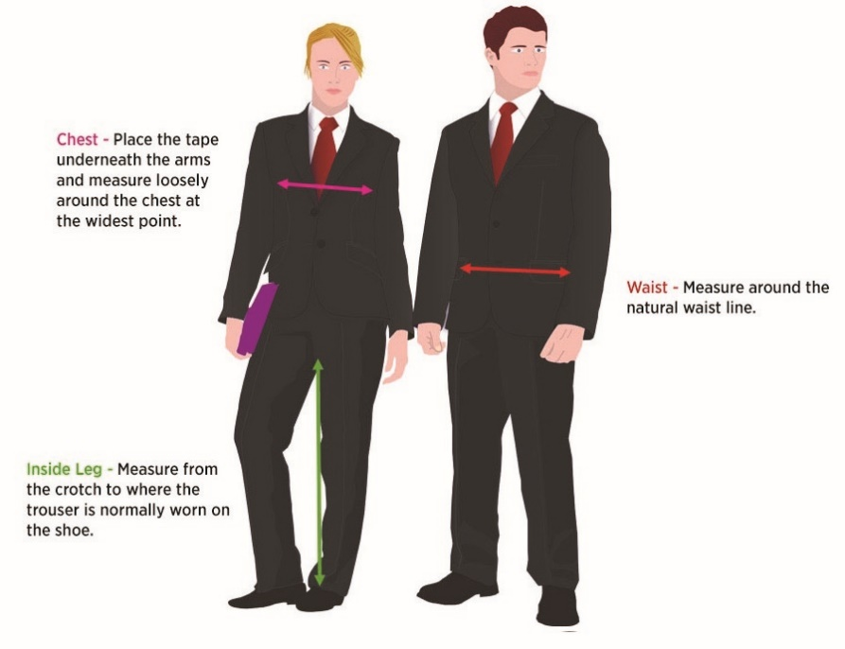
Measurements such as height are a better guide than age when choosing the correct size, so if your child is taller than average, it is advisable to order the next size up in tops or trousers.
If you have any questions or concerns about the sizing of our garments, don't hesitate to get in touch with the Just Schoolwear team.

Just School wear shops

Arnold Store Long Eaton Store
12 High Street 73 Derby Road
Arnold Long Eaton
Nottingham Nottingham
NG5 7DZ NG10 1LU
0115 9652869 0115 9652869

West Bridgford Store
11 Compton Acres Shopping Centre
West Bridgford
Nottingham
NG2 7RS
0115 9652869

