**Important Information - Exam Results 2023**

**Collection of Results**

**A Level results will be published on Thursday 17 August**. They can be collected from the Post 16 Common Room 8.00 until 10.30am.

**GCSE results will be published on Thursday 24 August**. They can be collected from the Main School Hall 8.00am until 11.00am.

Alternatively if you are unable to make it in person and wish for a family member to collect your results or for your results to be emailed to you please complete an “Alternative Results Collection” form. Please email mmcleodbrown@emmanuel.notttingham.sch.uk to request a form or see Appendix A of this document. Please return the signed and completed form to the Exams Officer by Friday 20th July 2023. Unless you have completed and returned the form results will not be emailed or handed to another person.

Results will not be provided over the telephone under any circumstances. Student grades will go live on Go4Schools from 11am on results day.

A number of teachers and senior members of staff will be available on each results day if you wish to discuss your results.

**Post Results Services**

**Enquiries About Results**

All Examination Boards provide a number of enquiry about results services which are available to students following the publication of results.

**The following services are available:**

* Review of marking – an examiner will review the original marking to ensure the agreed mark scheme has been applied correctly.
* Priority review of marking (A Level only) – the same as a review of marking, but the application is processed as a priority where a University or Higher Education place is dependent on the result.
* Clerical re-check – a re-check of all clerical procedures to ensure the marks have been correctly added up, all the pages have been included in the marking or additional sheets etc. The marking is not reviewed with this service.
* Re-moderation of coursework – this service may only be requested by the relevant Head of Department. Re-moderation involves the re-moderation of the whole cohort and cannot be requested for single pieces of work.

**The deadlines are:**

* Enquiries About Results – Monday 9 September
* Priority Enquiries About Results (A level only) – Friday 16 August

If you wish to request a post results service please email [mmcleodbrown@emmanuel.nottingham.sch.uk](mailto:mmcleodbrown@emmanuel.nottingham.sch.uk) Your request will be forwarded to a senior member of staff for review. If approved you must provide a signed consent and pay the relevant fee which you can pay through Parent Mail. For fee information, please see the fees section of this document.

**Importantly there are three potential outcomes to Enquiries About Results:**

* No change to the original mark/grade.
* The original mark/grade is increased.
* The original mark/grade is lowered. If the mark/grade is lowered you cannot ask for the original mark/grade to be re-instated.

Please be aware that this may affect your place at University or College.

In certain circumstances when a unit or overall subject grade has been amended you may be eligible for a refund, the Exams Officer will contact you if this is the case.

**Access to Scripts**

All Examination Boards provide access to script services which are available to students following the publication of results.

**The following services are available:**

* Access to Script – if you wish to have a copy of your exam script, usually if you intend to re-sit the qualification.
* Priority Access to Script – if you wish to view your script to help you decide if it should be reviewed.

**The deadlines are:**

* Access to Scripts – Thursday 28 September
* Priority Access to Scripts (A level only) – Thursday 24 August

**Fees**

The costs detailed below are per unit. Payment must be made via ParentMail before any request is processed. Once your post results request has been approved by a senior member of staff you will see the payment available on ParentMail.

Please note it is no longer possible to pay by cash or cheque.

|  |  |  |
| --- | --- | --- |
| **Service** | **GCSE Fee** | **AS and A Level Fee** |
| Clerical re-check | £8.70-£12.50 | £8.70-£12.50 |
| Review of marking | £40.35-£44.50 | £46.75-£57.50 |
| Priority review of marking | N/A | £55.60-£70.75 |
| Access to scripts | Free | Free |

**Appeals**

The appeals process is available to candidates who remain dissatisfied after receiving the outcome of an enquiry about results.

Appeals can only be submitted by the Head of Centre and must be made in writing within 14 calendar days of the notification of the outcome. This means the date at which the school was notified of the outcome. The appeal must clearly state the grounds for appeal and will not normally result in a second re-mark but must refer to the awarding body’s failure to follow procedure.

It is essential that any appeal is dealt with as a matter of urgency and be supported by school staff.

Please contact the Exams Officer, in the first instance, if you wish to appeal the outcome of a post results enquiry [mmcleodbrown@emmanuel.nottingham.sch.uk](mailto:mmcleodbrown@emmanuel.nottingham.sch.uk) .

**Further Information**

If you have any queries or would like further information please contact the Exams Officer via email at [mmcleodbrown@emmanuel.nottingham.sch.uk](mailto:mmcleodbrown@emmanuel.nottingham.sch.uk)

Appendix A

Alternative Results Collection Form

If you require your results by an alternative method to collection in person, please complete this form and return to the Exams Officer by 20 July 2023.

| **Candidate Name:** |
| --- |
| Please email my results to my school email address  @emmanuel.nottingham.sch.uk  Please note results cannot be emailed to personal email addresses. |
| I give permission for my representative (insert name)  to collect my results on my behalf. I confirm that my representative will provide photographic ID on collection. |
| Candidate Signature: |
| Date: |

Appendix B

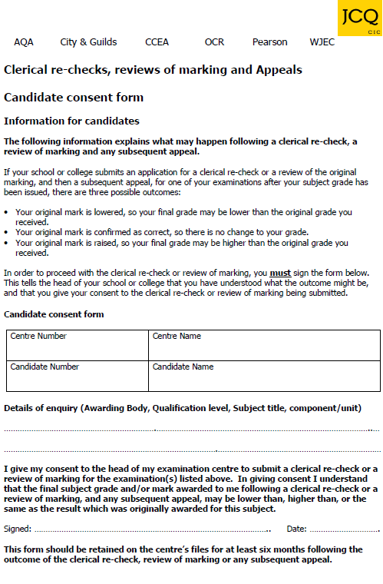

Appendix C

